MUHAMMAD DANIAL AKMAL B. ROSLI (273046)

QUIZ 3

**1.**

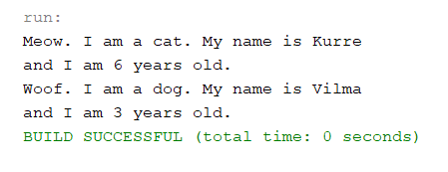

**2. The instance variable age is inherited from Animal as the main class.**

**3. An instance consists of its own variables.**

**4. A class consists of variables, methods, data and comments.**

**5. Class is the blueprint for the objects, while instance is object contained in the class.**

**6. Meow. I am a cat. My name is Kurre**

**and I am 3 years old.**

**Woof. I am a dog. My name is Vilma**

**and I am 3 years old.**

**This is because static keyword can be accessed for only once.**

**7. The value of instance variable is stored inside memory.**

**8. The value of class variable is stored inside memory.**

**9. Variable “this” refers to the items inside the method / constructor.**